Programer’s Manual



Created by Underdog Technologies

Members: Connolly Dean, Terry Ford, Ben Vuong, Eddie Lemmon, Furkan Goren

Project: ArcGis Scavenger Hunt

Revision 1: 11/8/2022 - Initial rough draft

Revision 2: 11/17/2022 - added in a logo

# Section 1. Assumptions:

* A basic knowledge of GIS technology and the ArcGis Pro program
* An understanding of gitlab and how to maintain its repository

# Section 2. High Level Design:

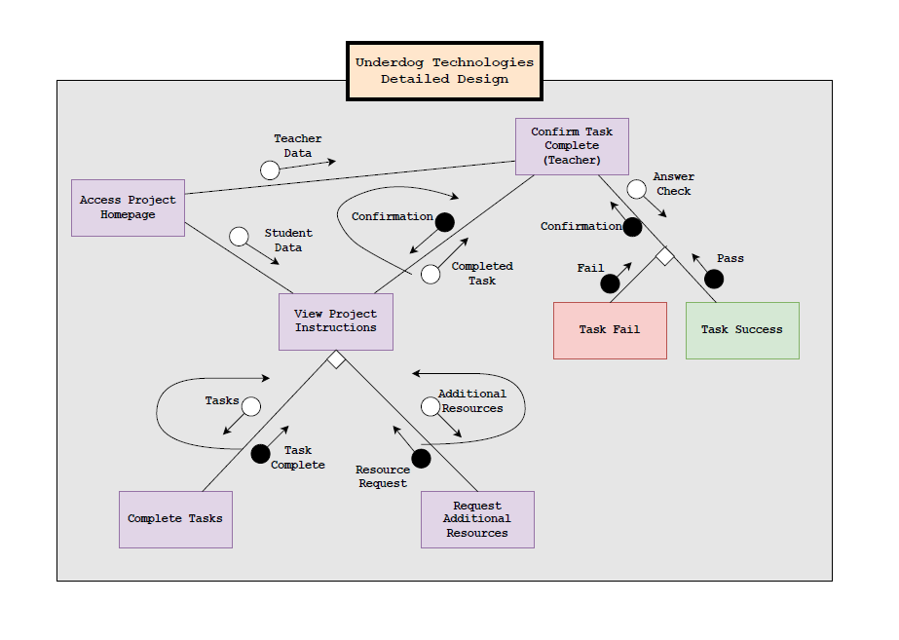

Above is our detailed design for this project. The goal of the project is to be able to teach young students about GIS and how to use it. This is done by teaching them through tutorials. These tutorials will be stored and organized in the repository. The tutorials will be organized in separate folders along with its own scavenger hunt prompt once they have completed the tutorials. Now along with the tutorials and resources for the students being stored in the repository, resources for the teachers like the answers to the scavenger hunt and detailed documentation of the GIS program will be there in the repository. These teacher’s resources will only be available for the teacher and the student would not be able to access them within the repository.

# Section 3: More Detailed Designs:

Now that we have summarized the overall design and purpose of the project lets see each section of the design model in detail.

## Section 3.1 Access the Project Homepage:

Once either the student or the teacher get access to the repository homepage, they will see folders named by its sections and a snippet of the latest commit made to the repository. Here students will only be able to see and access the folders that have the tutorials designed for them, while teachers will have both the student tutorials and answers to the questions and extra documentation.

## Section 3.2 View project instructions:

Once the students are able to view the repository with all of the different section folders, they will start off with section 1 and continue on there. Once they open up a section folder they will have access to a text document that will explain the tutorials and what they should do. Accompanying that text document will be demo video tutorials that will walk them through the tutorials if needed. Once they are done with the section and have been able to understand what they were taught in that section they then move on to the scavenger hunt section.

## Section 3.3 Scavenger Hunt:

Once they are done with the tutorials of a section they will find a text document explaining how a scavenger hunt is done overall and are given a starting clue to lead them on their way. The scavenger hunt of each section will be crafted so that the topic and techniques learned in those sections will be important to use to find the answer to the scavenger hunt. Once the students have found their answer they will report the teacher. The teacher will have access to the answer of all of the scavenger hunts and will be able to tell the students if they are right or wrong.